CentOS server install part 2

Check machine’s IP address information on all network interfaces:
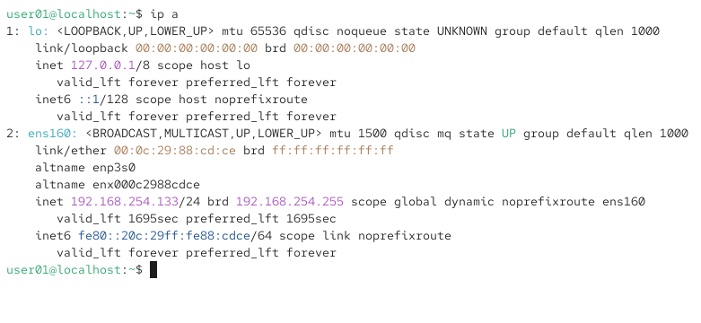

Check network interfaces since this is setup with a NAT we only have loopback and ethernet showing up:
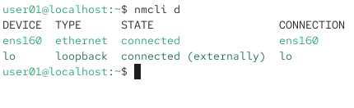

Update the kernel: 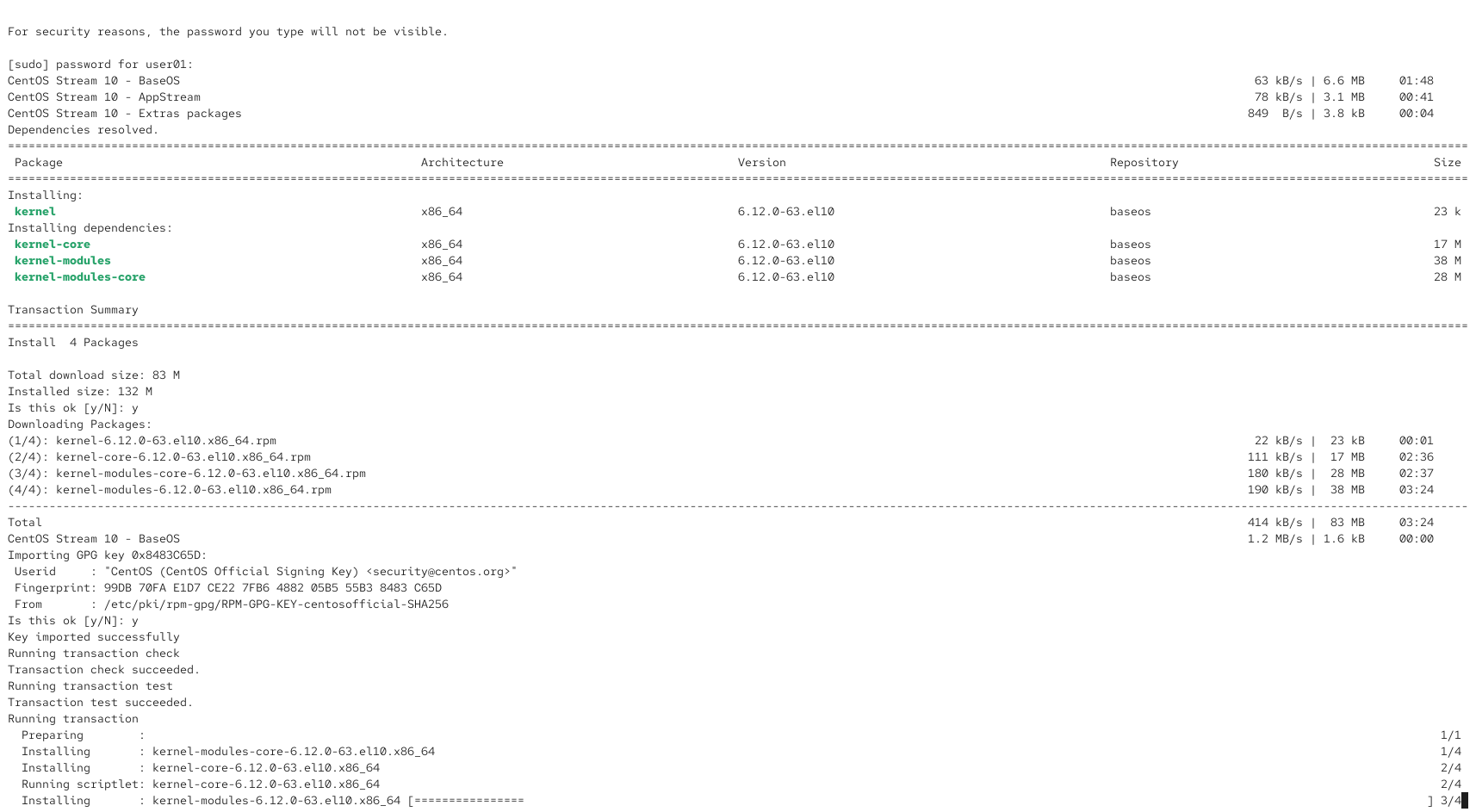

Afterwards we run upgrade in the same command by using &&, but after the auto-reboot of the machine no login prompt is showing, we can try using the backup terminal which comes with CentOS to continue:

After creating a new user the log in prompt shows up (I’m not sure why my original user account didn’t I may have forgotten to save it somehow but it works now):
Now we can confirm the upgrade has been successful:
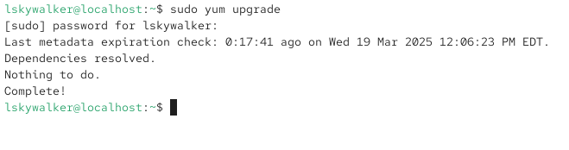

Now we’ll install the gcc package:
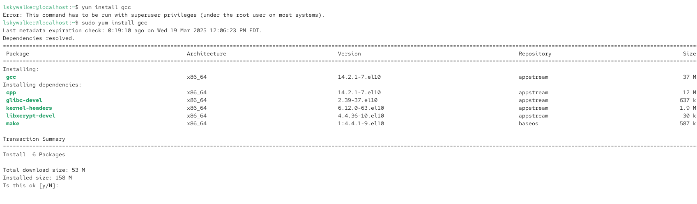

And the httpd package:
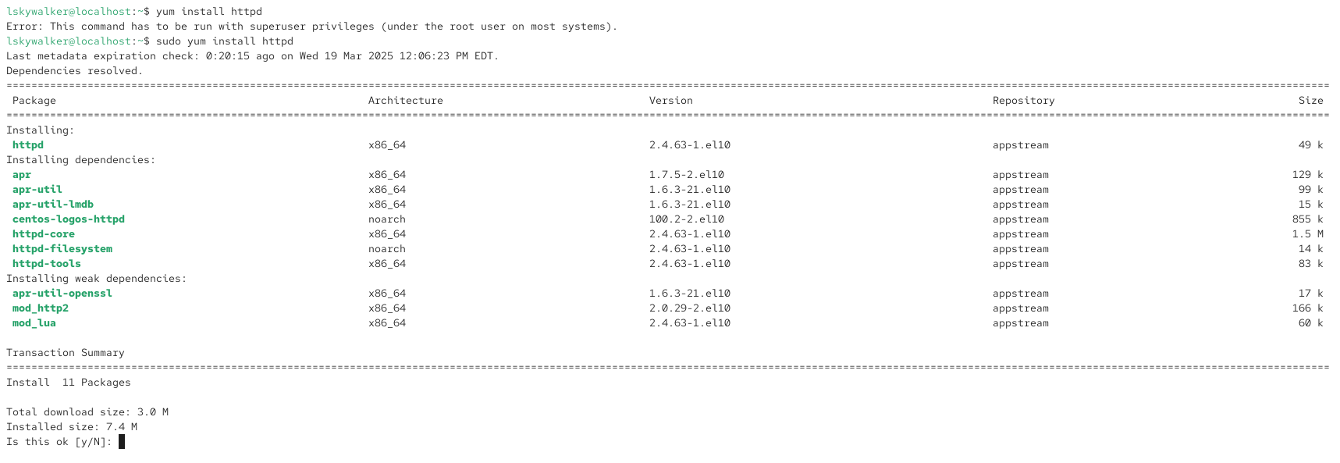

The last package we’re installing for now is php so we install it the same as the others:
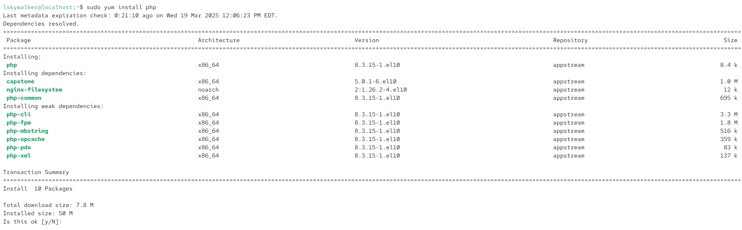

Now we can add another user:
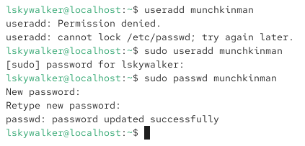

Now both users are present on the sign in screen:
